77th PCT NCO Sector Meetings Revised 8-10-21
NCO Sector | NCO Meeting Date | NCO Meeting Time | NCO Meeting Location | NCO Officer | NCO Officer Email | NCO Officer  Contact Number
NCO Supervisor |  |  |  | SGT Anthony Bertram | Anthony.Bertram@nypd.org | 718-735-6070
A | July 24, 2021 | 5:30 PM | Stroud Park  483 Park Ave | PO Elias Wallen | Elias.Wallen@nypd.org | 917-287-4722
 |  |  |  | PO Daniel Staffa | Daniel.Staffa@nypd.org | 929-291-8659
B | August 12, 2021 | 5:30 PM | Community Garden  1100 Bergen St | PO Stephanie Perez | Stephanie.Perez2@nypd.org | 929-215-6472
 |  |  |  | PO Matthew Melendez | Matthew.Melendez@nypd.org | 917-513-5931
C | August 25, 2021 | 5:30 PM | Brower Park  195 Brooklyn Ave | PO Malcolm Brissett-Ortiz | Malcolm.BrissettOrtiz@nypd.org | 917-521-9880
 |  |  |  | PO Corey Mott | Corey.Mott@nypd.org | 929-465-4250
D | September 22, 2021 | 5:30 PM | Religious Hall  1425 Lincoln Pl | PO Saskya Rodriguez | Saskya.Rodriguez@nypd.org | 917-756-3285
 |  |  |  | PO Michael Napolitano | Michael.Napolitano@nypd.org | 917-376-8807

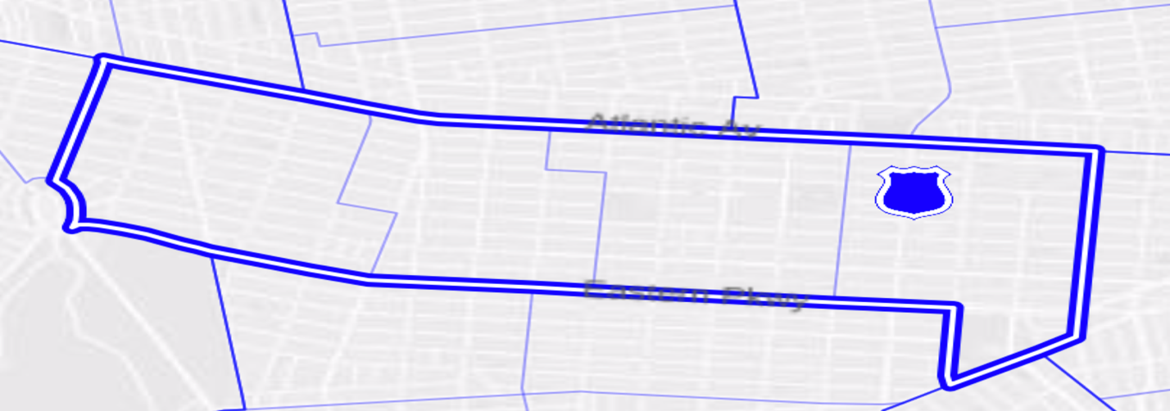
E New York Ave
Rochester Ave
Ralph Ave
Schenectady Ave
C
Brooklyn Ave
Bergen St
New York Ave
B
A
Bedford Ave
Park Pl
Vanderbilt Ave
Franklin Ave
D

78th PCT NCO Sector C Meeting within CB8 Revised 2-24-21
NCO Sector | NCO Meeting Date | NCO Meeting Time | NCO Meeting Location | NCO Officer | NCO Officer Email | NCO Officer Cell Number
NCO Supervisor |  |  |  | SGT Anthony Dimichele | Anthony.Dimichele@nypd.org
C | September 18, 2021 | 1:00 PM | Zoom Meeting ID: 161 089 5283 Passcode: h*Sue3?Y | DET Stella Gause | Stella.Gause@nypd.org
 |  |  |  | PO Elizabeth Medina | Elizabeth.Medina@nypd.org

