77th PCT NCO Sector Meetings Updated 8-4-20
NCO Sector | NCO Meeting Date | NCO Meeting Time | NCO Meeting Location | NCO Officer | NCO Officer Email | NCO Officer  Contact Number
NCO Supervisor |  |  |  | SGT Anthony Bertram | Anthony.Bertram@nypd.org | 718-735-6070
A | Friday  August 21, 2020 | 6:00 PM | Stroud Playground  750 Classon Avenue  Brooklyn, NY 11238 | PO Tahir Malik | Tahir.Malik@nypd.org | 929-291-1527
 |  |  |  | PO Daniel Staffa | Daniel.Staffa@nypd.org | 929-291-8045
B | Thursday  August 6, 2020 | 6:00 PM | Community Garden  1107 Bergen Street  Brooklyn, NY 11238 | PO Stephanie Perez | Stephanie.Perez2@nypd.org | 929-215-6472
 |  |  |  | PO Matthew Melendez | Matthew.Melendez@nypd.org | 917-513-5931
C | Wednesday  August 12, 2020 | 6:00 PM | Brower Park  145 Brooklyn Avenue  Brooklyn, NY 11213 | PO Malcolm Brissett-Ortiz | Malcolm.BrissettOrtiz@nypd.org | 917-521-9880
 |  |  |  | PO Corey Mott | Corey.Mott@nypd.org | 929-465-4250
D | Thursday  August 27, 2020 | 6:00 PM | Lincoln Terrace Park  398 Buffalo Avenue  Brooklyn, NY 11213 | PO Michelle Giglio | Michelle.Giglio@nypd.org | 929-291-1309
 |  |  |  | PO Michael Napolitano | Michael.Napolitano@nypd.org | 917-376-8807

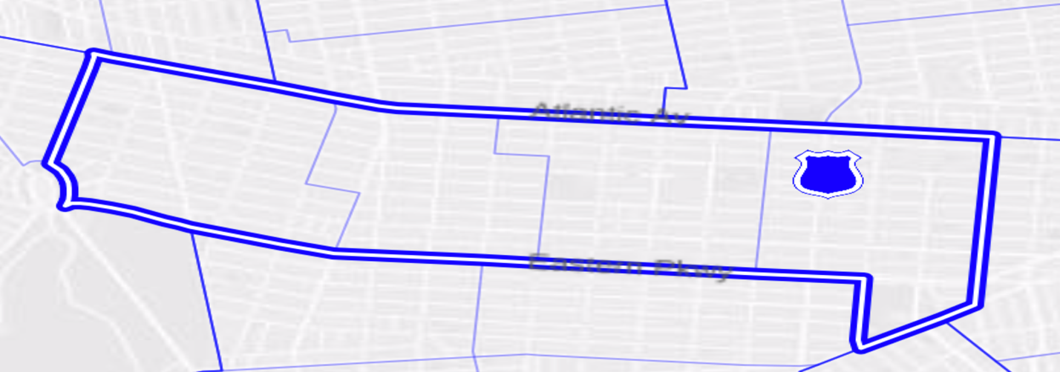
E New York Ave
Rochester Ave
Ralph Ave
Schenectady Ave
C
Brooklyn Ave
Bergen St
New York Ave
B
A
Bedford Ave
Park Pl
Vanderbilt Ave
Franklin Ave
D

78th PCT NCO Sector C Meeting within CB8 updated 8-4-20
NCO Sector | NCO Meeting Date | NCO Meeting Time | NCO Meeting Location | NCO Officer | NCO Officer Email | NCO Officer Cell Number
NCO Supervisor |  |  |  | SGT Anthony Dimichele | Anthony.Dimichele@nypd.org
C | Thursday  August 6, 2020 | 7:00 PM | 6th Avenue Bible Baptist Church  97 Lincoln Place  Brooklyn, NY 11217 | DET Stella Gause | Stella.Gause@nypd.org
 |  |  |  | PO Elizabeth Medina | Elizabeth.Medina@nypd.org

